JOSE REY GRANDEA
BSIT 3A
DATABASE SQL EXAM
10 SIMPLE SELECT QUERIES TASKS

1: Display All Records
SQL :
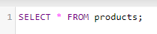
OUTPUT:
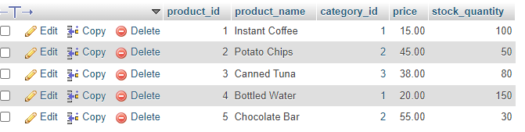

2: DISPLAY SELECTED COLUMN
SQL:
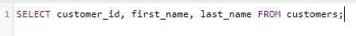
OUTPUT:
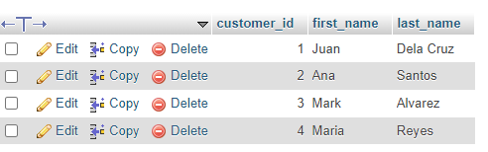

3. FILTER USING WHERE
SQL:
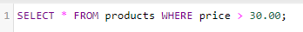
OUTPUT: 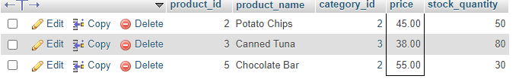

4. Filter Using AND
SQL
OUTPUT
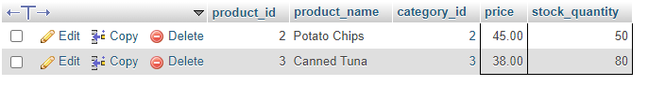

5. Filter Using OR
SQL
OUTPUT
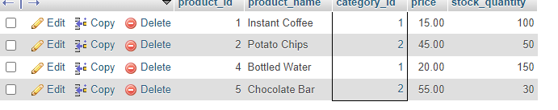

6. Sort Records
SQL
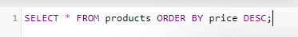

OUTPUT
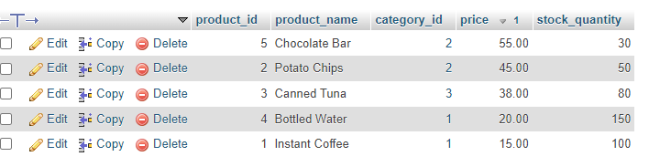

7. Pattern Matching
SQL
OUTPUT
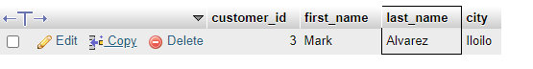

8: Range Filtering
SQL
OUTPUT
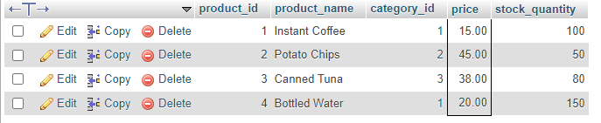

9: Simple JOIN
SQL
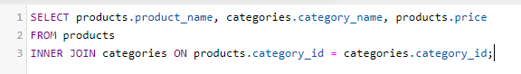

OUTPUT
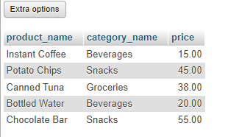

10: Transaction Report
SQL
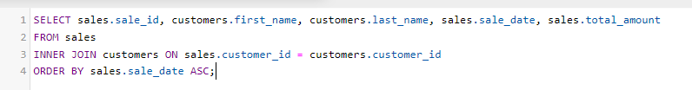
OUTPUT
